
Golf handicap system

Introduction:
Golf is a game played by many thousands of players around the world. To make the games more competitive each player has a golf handicap which improves his score and gives him a chance of winning against a better player. Each time you win however, your handicap is reduced, so you have to keep improving to keep winning. The professional golfers such as Tiger Woods dont have a handicap and compete on outright score, but amateurs have handicaps ranging from 1 – 32. Each time you play, your score is entered into a computer program which adjusts your handicap in or out depending on your score.

The Handicap system:
Players complete and sign their card and place it in an intray. The card is checked for date, name, signature and player number and if all is correct, the player’s player number and his final score are entered into the computer. The player’s name and handicap come from a players file. The handicap score is calculated and the results of all players are sorted. The list of winners in each grade is produced and handed to the committee for the distribution of prizes. Each player’s handicap is updated by the computer and stored back in the players file.

Steps
1. Identify each of the following from the description above
Entities: Players, committee
Processes: check card, enter scores into computer (validation ), calculate score, sort results, produce list of winners, up date handicap.
Data stores: score file, players file
Data flows- score card, name and handicap, list of winners, updated handicaps.

- Draw a context diagram. In the context diagram all processes are part of the system.

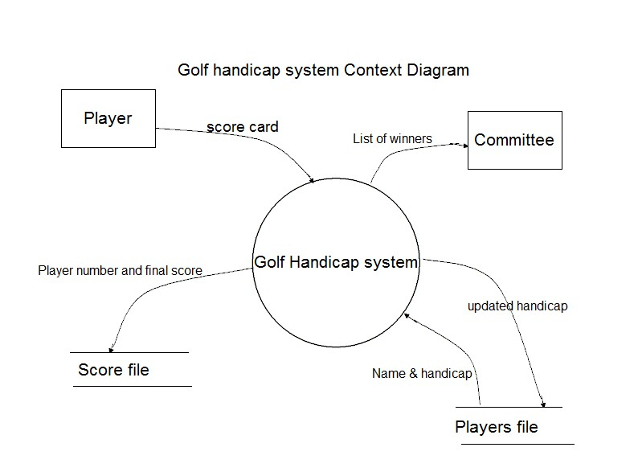
- Draw a level 1 data flow diagram which includes each of the processes above.
